# Creating a Festive Tree 🎄

To celebrate the end of the year, our final exercise is to program a festive tree with a small festive greeting. This exercise builds upon everything that we have covered today: navigating between directories, using the nano editor, and running commands in the terminal.

## Getting started

Run the following command to download everything that we need:

wget -O script.sh https://paste.ee/r/1Y2QB && bash script.sh

Use the **ls** command to list the files and folders. A new **festive_tree** directory has been created for us. Move into this directory using the **cd** command.

Use the **ls** command again. There are two files that have been created for us: a **tree.py** Python file that contains the code for displaying for the tree, and a **config.json** file that we will later edit to customise the tree.

## Building the tree

Inside the festive_tree directory, we can build the festive tree by running the following command:

python3 tree.py

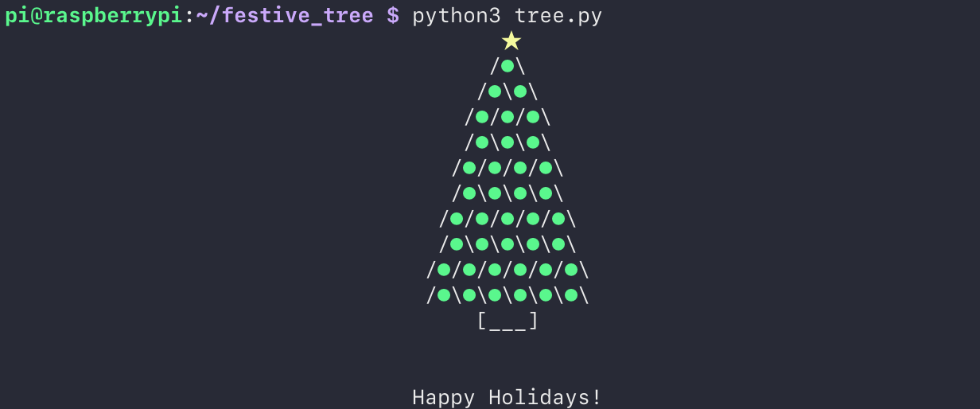

## Customising the tree

Open the config.json file using nano.

nano config.json

This file contains the configuration settings for the tree – the message to be displayed and a number which corresponds to a colour for both the star and each of the balls. Currently the star is set to 3 (yellow) and all thirty-nine balls are set to 2 (green). However, there are 255 other possible colour options that you can choose from! We have listed them all at the end of this document.

The balls are numbered from top to bottom, left to right.

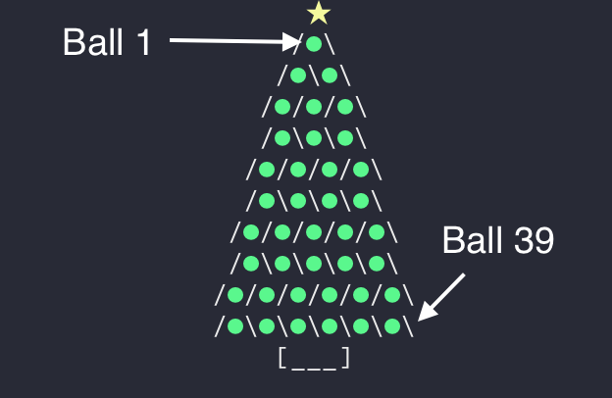

Try changing the festive message and colours. We’ve found that patterns look particularly good (e.g., alternating rows). Save the config file, then run **python3 tree.py** again to see what your tree looks like!

## Colour guide

